**Working with file contents**

1. Display the first 12 lines of **/etc/services**.

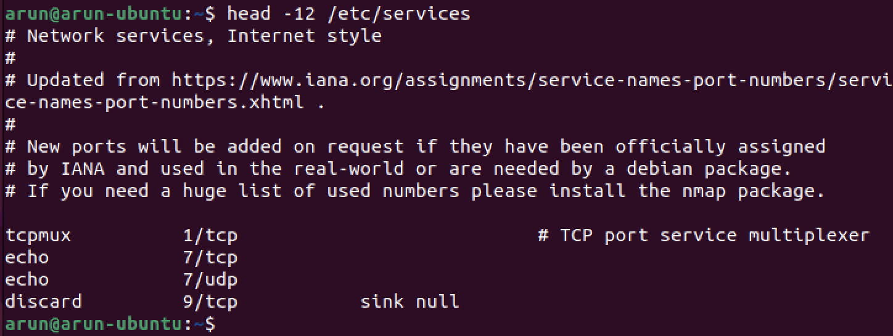

1. Display the last line of **/etc/passwd**.



1. Use cat to create a file named **count.txt** that looks like this:

Hello

How are you?

How is your Linux practical going on?

Today we are using linux command for using file content.



1. Use **cp** to make a backup of this file to **cnt.txt**.



1. Use **cat** to make a backup of this file to **catcnt.txt**.
2. Display **catcnt.txt**, but with all lines in reverse order (the last line first).
3. Use more to display /etc/services.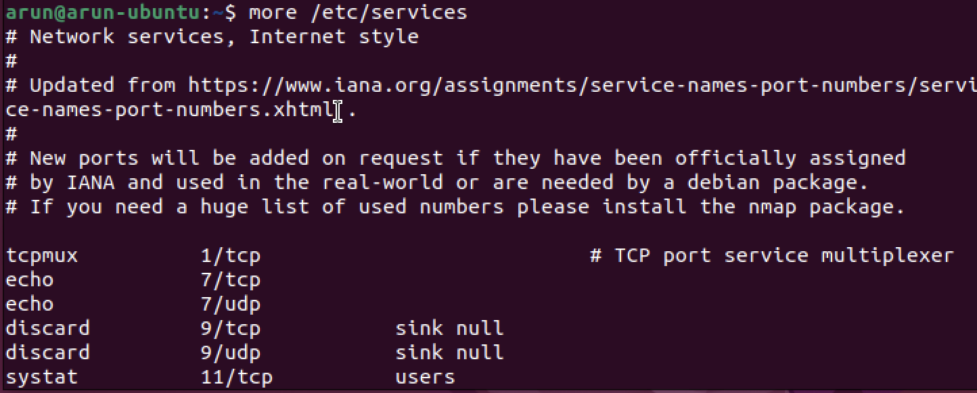
4. Display the readable character strings from the **/usr/bin/passwd** command.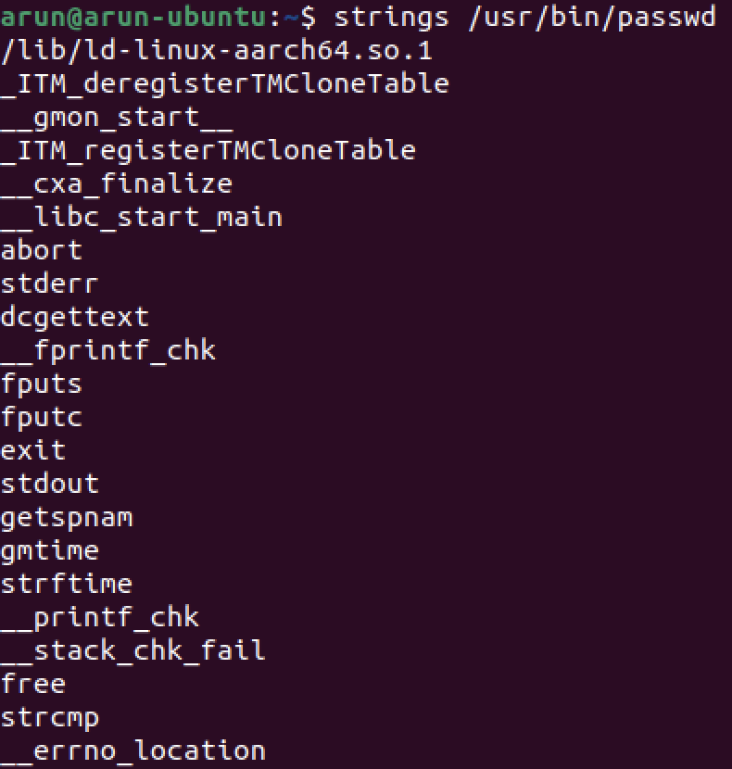
5. Use **ls** to find the biggest file in **/etc**. 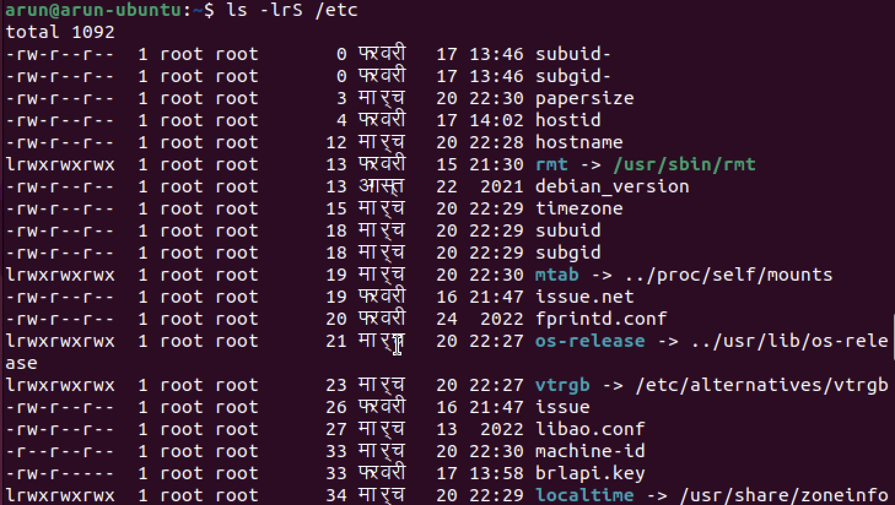
6. Open two terminal windows (or tabs) and make sure you are in the same directory in both. Type **echo this is the first line > tailing.txt** in the first terminal, then issue **tail -f tailing.txt** in the second terminal. Now go back to the first terminal and type **echo This is another line >> tailing.txt** (note the double >>), verify that the **tail -f** in the second terminal shows both lines. Stop the **tail -f** with **Ctrl-C**. 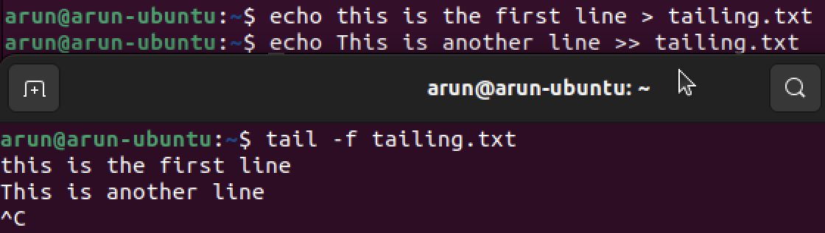
7. Use **cat** to create a file named **tailing.txt** that contains the contents of **tailing.txt** followed by the contents of **/etc/passwd**.

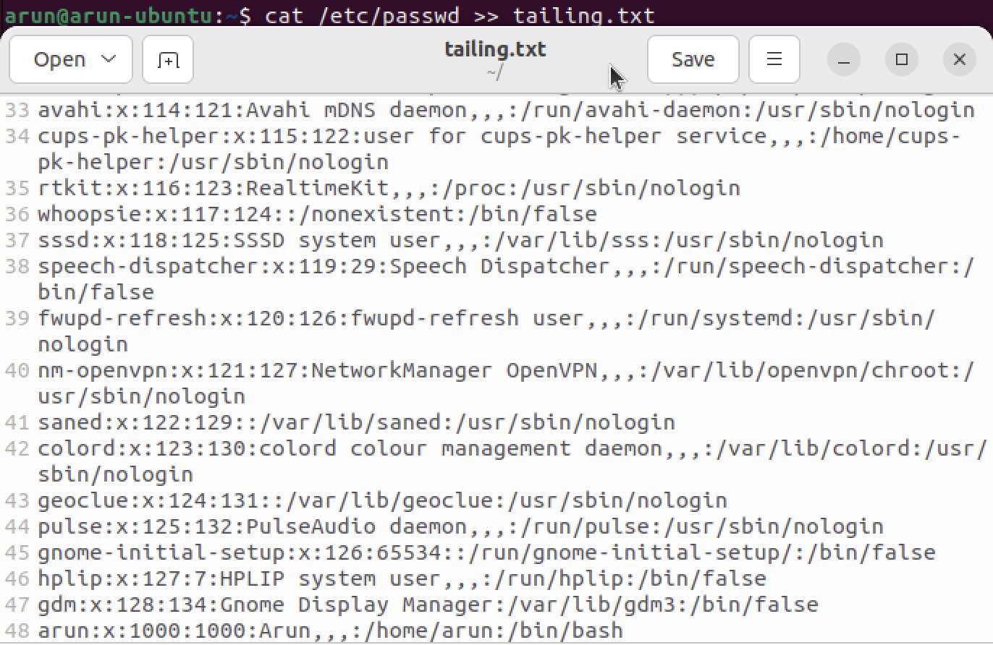

1. Use **cat** to create a file named **tailing.txt** that contains the contents of **tailing.txt** preceded by the contents of **/etc/passwd**.

